Macrosystems EDDIE:

Teleconnections

**Instructor’s Manual**

# Module Description

Ecosystems can be influenced by *teleconnections*, in which meteorological, societal, and/or ecological phenomenon link remote regions via cause and effect relationships. Because it is difficult to predict how ecosystems will respond to drivers from remote regions, many researchers are using models to simulate different teleconnection scenarios and see how ecosystems respond. For example, lake simulation models provide a powerful tool for exploring how lake thermal structure and ice cover respond to climate teleconnections such as the El Niño/Southern Oscillation (ENSO). In this module, students will learn how to set up a lake model and "force" the model with climate scenarios to test hypotheses about how far-away drivers interact with local lake characteristics to affect lake temperatures and ice cover in different lakes. The overarching goal of this module is for students to explore new modeling and computing tools while learning fundamental concepts about how teleconnections affect lake temperatures and ice cover.

# Pedagogical Connections

|  |  |  |
| --- | --- | --- |
| **Phase** | **Functions** | **Examples from this module** |
| Engagement | Introduce topic, gauge students’ preconceptions, call up students’ schemata | Short introductory lecture |
| Exploration | Engage students in inquiry, scientific discourse, evidence-based reasoning | Developing hypotheses of how teleconnections affect lakes; testing hypotheses by forcing lake models with El Niño scenarios to see how different lakes respond |
| Explanation | Engage students in scientific discourse, evidence-based reasoning | In-class discussion of the different effects of the El Niño Southern Oscillation on lake temperatures and ice cover in lakes from different regions |
| Expansion | Broaden students’ schemata to account for more observations | Assessing teleconnections by comparing how lakes from different regions respond to the same environmental phenomenon; predicting how lakes in other regions would respond to El Niño events |
| Evaluation | Evaluate students’ understanding, using formative and summative assessments | In-class discussion of how teleconnections can affect water temperatures and ice cover in lakes |

# Learning Objectives

By the end of this module, students will be able to:

* Understand the concepts of macrosystems ecology and teleconnections, and how different ecological processes can interact at local, regional, and global scales.
* Set up and run ecosystem models to simulate lake temperatures and ice cover in multiple lakes (Activity A).
* Test the effects of teleconnected climate scenarios on the different lake models, and examine how local characteristics modify global-scale climate forcing effects on lake temperatures and ice cover (Activity B).
* Compare the role of teleconnections in driving lake temperatures and ice cover across multiple lakes in different regions (Activity C).
* Predict how lake temperatures and ice cover may respond to changes in the timing and intensity of global-scale meteorological phenomena (Activity C).

# How to Use this Module

This entire module can be completed in one 3-hour lab period or three 60-minute lecture periods for senior undergraduate students or graduate students. We found that teaching this module in one longer lab section with short breaks was more conducive for introductory students than multiple 1-hour lecture periods.

This module is recommended for upper-level undergraduate and graduate-level Ecosystem Ecology, Freshwater Ecology, Global Change Ecology, Climate Science, and Environmental Science courses. Module materials can be tailored to increase or decrease the background information depending on students' quantitative skills. Depending on the number of students and their experience level with R software, having additional instructors available to answer questions is useful, particularly if students have limited prior experience using R (e.g., we found that a 10:1 student:teacher ratio or smaller worked well in our classes).

It is helpful for the instructor to have a working knowledge of R and the General Lake Model (GLM) to help troubleshoot and respond to student questions. We provide a brief introduction to R and GLM as part of the Teaching Materials, below.

Quick overview of the activities in this module

* **Activity A:** Students run a lake model, and plot lake temperatures and ice cover from numerous lakes in different regions, using real climate driver data.
* **Activity B:** Students modify climate driver data to simulate two different El Niño scenarios for their model lake, generate hypotheses, and then use the GLM model to see how different lakes respond.
* **Activity C:** Students discuss the relative strength of El Niño teleconnections in altering water temperatures among lakes in different regions, and make predictions about how lakes may respond to changes in the timing and intensity of global-scale meteorological phenomena.

# Module Workflow

1. Have students install R and RStudio software on their laptops before class (send them the "R You Ready for EDDIE" file for step-by-step directions).
2. Give students their handout ahead of time to read over prior to class, or distribute handouts when they arrive to class.
3. Instructor gives brief PowerPoint presentation on how macrosystems ecology can be used to understand teleconnections, using the example of how far-away meteorological phenomena can affect lake temperatures and ice cover. The PowerPoint also includes an overview of the GLM model that will be used in the module.
4. After the presentation, the students divide into pairs, with each pair selecting a different lake to model from the list of available lakes, then set up the GLM files and R packages on their computer to run their lake model and explore the output (Activity A).
5. The instructor then introduces Activity B.
6. Students analyze local long-term climate data to explore how El Niño affects air temperatures around their focal lake and create hypotheses about how air temperature changes due to El Niño could affect lake temperatures and ice cover in the future. They then modify model driver data to force the lake with realistic “typical” and “strong” El Niño meteorological scenarios, and analyze the output to determine how El Niño teleconnections alter lake temperatures and ice cover (Activity B).
7. After analyzing their model output, pairs of students create some figures to present their El Niño scenarios and resulting model outputs to the rest of the class, contrasting El Niño scenarios and lake responses among lakes from different regions.
8. The instructor then moderates a discussion of the effects of the El Niño scenarios on different lakes, and how individual lake responses could change in the future if the timing or intensity of global-scale meteorological phenomena like El Niño changes (Activity C).

**Important Note to Instructors:**

The R packages used in this module are continually being updated, so these module instructions will periodically change to account for changes in the code. If you find any errors or have other feedback about this module, please contact the module developers (see “We’d love your feedback” below).

**We encourage instructors to read through and run the R code before teaching the module so that you are familiar with all of the steps of this activity.**

# Things to do prior to starting the instructor’s presentation

* Organize student pairs by operating system, such that Windows PC users are working together, and OS X Macintosh users are working together. It also helps for students to work with partners that have the same version of operating system (e.g., El Capitan vs. Yosemite vs. Sierra Mac OSX users; Windows 7 vs. Windows 8 vs. Windows 10 PC users), though it’s not necessary.
* Make sure that all students have downloaded R and RStudio successfully on their laptops (see “R You Ready for EDDIE?” file for step-by-step directions).
* While checking to make sure that everyone has R downloaded, have students that are ready and waiting type in some basic commands into the R interface (e.g., ‘2+2’) to explore its capabilities.
* Have the students read through the student handout, especially the ‘Why macrosystems ecology?’ and ‘Today’s focal question’ sections.

# Introductory PowerPoint Presentation

We have provided some text in the “Notes” of the PowerPoint slides that can be viewed when projecting in Presenter View.

# Activity A: Plot water temperature and ice cover in your model lake

Activity A challenges the students to set up and run a whole-lake simulation model, and create a plot of lake temperatures and ice cover, using real, high-frequency climate forcing data and inflow files (if their focal lake includes surface inflows!).

Ask the students to open the module R script. Before you let them work independently in their pairs, open the R script on your computer and project it to show them how to run lines of code, and also what lines of code correspond to Activity A.

**Important: Tell the students to read through the detailed annotation corresponding to each line of code before they run the code in R. The most important part of this module is understanding what the code is doing, which is provided in the annotation in extensive detail.** The annotation is the text that follows a line of code behind the # sign.

Lines designated with **##!!** indicate sections of the code where students **must** change something in order for the script to run correctly. If they try to run the script without reading carefully, they will likely miss these designations, fail to make an essential change, and get error messages on successive commands they try to run.

## Common stumbling blocks for Activity A include:

* If students have used RStudio before, they may have a lot of files open by default when they load RStudio. We recommend having students close all open files, except for the Teleconnections_R_Script.R file before they begin.
* If students have not unzipped the ‘teleconnections’ folder on their Desktop and opened the R script directly from the zipped folder, they will get error messages when trying to set their sim_folder and working directory during Objective 1. If this is the case, they will need to close RStudio, unzip the ‘teleconnections’ folder, and open the Teleconnections_R_Script.R from the ***un***zipped folder.
* In Objective 1, students may not know how to find their model lake folder path, which is needed to set the sim_folder. The R script has a placeholder sim_folder that students will need to edit to match their computer- if they downloaded the ‘teleconnections’ folder to the Desktop, they will need to change their computer name and their lake name. (e.g., sim_folder <- '/Users/**cayelan**/Desktop/teleconnections/Lakes/**LakeName**'). They can find their folder path by following these steps:
  + Navigate to the ‘teleconnections’ folder on the Desktop, then open the Lakes folder. Right click on the folder that matches the lake they want to model, then select **Properties** (Windows) or **Get Info** (Mac), then look under Location (Windows) or Where (Mac). Students will need to change their computer name in the R script folder path. They can find their computer name after Users (examples below):
    - **Windows**: C:/Users/***KJF***/Desktop/teleconnections/Lakes/***Mendota***
      * Here, the computer name is KJF, LakeName is Mendota. If Windows users try to copy and paste their folder path, they will need to check that the dashes in the R script are /, not \
    - **Mac**: Macintosh HD -> Users -> ***careylab*** -> Desktop -> teleconnections -> Lakes -> **Sunapee** 
      * Here, the computer name is careylab, LakeName is Sunapee

Note that they will also need to change “LakeName” in the R script path to be the name of their lake.

* If students are getting error messages when trying to install or load packages, they likely have an out-of-date version of R. They should download the current version of R, following the “R You Ready for EDDIE” document. Time spent on these errors can be minimized by encouraging students to try to install and update R and all packages ahead of time, following directions in the “R You Ready for EDDIE” file.
* Windows users may get an error when trying to run GLM commands, similar to: “gml.exe had status 309”. This error occurs on Windows due to a 32-bit vs. 64-bit incompatibility issue in RStudio. To fix it, click Tools, then Global Options. In the General tab, click on Change, then select the [Default] [32-bit] option. You will then need to restart RStudio and try the script again.
* If a student has opened the inflow.csv or met_hourly.csv files in Excel prior to the module, the datetime format will be corrupted to a version that GLM cannot recognize. This can cause R to give a number of errors, including:
  + Problems running the GLM model in Activity A, Objective 2. The command run_glm(sim_folder, verbose=TRUE) will start the GLM run, but you will likely get an error similar to: “Day 2451636 (2000-04-01) not found”
  + To fix this problem, we recommend that the student delete the folder of module files they have downloaded, and re-download the original zipped version (extracting the folder to the Desktop without opening any files!).

Walk around the pairs and make sure that everyone is able to follow along the R script successfully. When they are done with Activity A, they will produce a heatmap of water temperature across depths over time, as well as a line plot of ice cover over time. Once 90% of the class has finished with Activity A, return to the PowerPoint to introduce Activity B, and then make sure to help the remaining 10% of students finish Activity A after the others have started B.

* A technique that we have found helpful in “equalizing” a classroom with different skill levels and computer experience is to recruit the more advanced students that have finished an activity to assist the pairs that may be moving more slowly and have lots of questions.

# Activity B: Calculate a “typical” and a “strong” El Niño scenario, generate hypotheses, and model how the lake responds

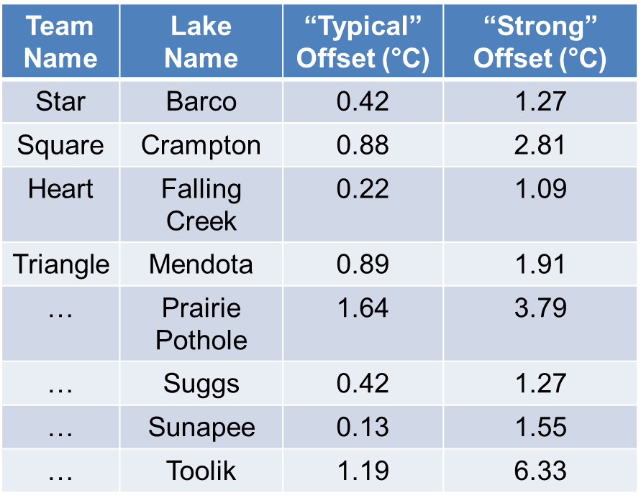This is a challenging activity because it involves hypothesis generation for different scenarios, so walking around the classroom to check in, and asking the students about their hypotheses is really important here to make sure they’re thinking through hypotheses rather than speeding through the script. We specifically created the student handout to try to slow down students and encourage them to think through the code that they are running.

To help students visualize the different offsets among lakes and between El Niño scenarios, we recommend drawing a blank grid on the board and having student teams write their lake name and associated offsets on the board. This can also help keep track of progress among groups during the module. The example grid at right includes the offsets students will calculate for their scenarios, for reference.

**Important: tell the students up front that they will need to prepare some figures (e.g., plots of their lake temperature heat maps and ice cover line plots generated from their model output) to share with the other students.**

## Common stumbling blocks for Activity B include:

* Forgetting to change the glm2.nml file and/or forgetting to save changes to the file. After they use the script to create a new meteorological driver file for each El Niño scenario, students must manually change the **meteo_fl** entry in their glm2.nml file (e.g., from met_hourly.csv to met_hourly_scenario2.csv or met_hourly_scenario3.csv). If the glm2.nml file is not changed ***and saved***, the students will simply be re-running the baseline model. In the script, students should be stopping to check for this—the command View(lakeTemp_output) in Objective 3 will open the temperature output file, and students should briefly scroll through some of the dates in the file to check that surface temperatures are not the same between the baseline and “typical” El Niño scenario. Note that for many lakes, temperatures will be *very* similar, particularly near the start of the model run, but they should not be identical.
* If student line plots for Activity C are fully overlapping (i.e., you can only see one line with no deviation between scenarios), they did not successfully change their scenarios, and simply reran the baseline simulation three times. For all of the lakes, even those with the small offsets (see table above), there should be some differences visible among scenario outputs. Having them visually check during Objective 3 will help avoid this.

# Activity C: Compare lake responses to El Niño scenarios, and examine how local and regional characteristics mediate lake responses to global climate teleconnections

At the end of Activity C, spend some time going around the classroom so that each student pair can show what their lake-specific El Niño scenarios were, and what the output looked like. Ask probing questions and try to initiate a class discussion in which the other students respond to questions, and ask their own. See the final page of the Answer Key at the end of this document for potential discussion questions.

# Resources and References

## Optional pre-class readings and web materials:

* Heffernan, J.B., et al. 2014. Macrosystems ecology: understanding ecological patterns and processes at continental scales. Frontiers in Ecology and the Environment 12: 5-14.
* National Oceanic and Atmospheric Administration "El Niño-Southern Oscillation" website: <https://www.climate.gov/enso>

## Tools and high-frequency data that we will use in this module:

* Hipsey, M. R., L.C. Bruce, and D.P. Hamilton. 2014. GLM- General Lake Model: Model overview and user information. AED Report #26, The University of Western Australia, Perth, Australia. 42 pp.
* Read, J.S., and L.A. Winslow. 2016. glmtools R package v.0.14.6.
* Winslow, L.A., and J.S. Read. GLMr R package v.3.1.15 and GLMr R package default files. GLMr: A General Lake Model (GLM) base package.

## Recent publications about EDDIE modules:

* Farrell, K.J., and C.C. Carey. 2018. Power, pitfalls, and potential for integrating computational literacy into undergraduate ecology courses. Ecology and Evolution 8:7744-7751. DOI: 10.1002/ece3.4363
* Carey, C. C., and R. D. Gougis. 2017. Simulation modeling of lakes in undergraduate and graduate classrooms increases comprehension of climate change concepts and experience with computational tools. Journal of Science Education and Technology 26:1-11.
* Klug, J. L., C. C. Carey, D. C. Richardson, and R. Darner Gougis. 2017. Analysis of high-frequency and long-term data in undergraduate ecology classes improves quantitative literacy. Ecosphere 8:e01733.

# We’d love your feedback!

We frequently update this module to reflect improvements to the code, new teaching materials and relevant readings, and student activities. Your feedback is incredibly valuable to us and will guide future module development within the Macrosystems EDDIE project. Please let us know any suggestions for improvement or other comments about the module at <http://www.macrosystemseddie.org>.

# Answer Key

The following plots are indicative of what student model output should look like (approximately!), if the module is run correctly. There may be some variation among operating systems and software versions.

## Activity A

**Objective 2:** Temperature heatmaps and lake level (depth) line plots from GLM model output

Students should note differences in water temperature with depth, and how that changes as the year progresses. Note that in spring, the lakes begin to stratify, with warmer water near the surface (epilimnion) and cooler water deeper (hypolimnion). **Note:** It is important when comparing plots for students to note the minimum and maximum values represented by the different colors, as these can change between plots depending on the overall range of values being visualized!

Example lake temperature heat map:

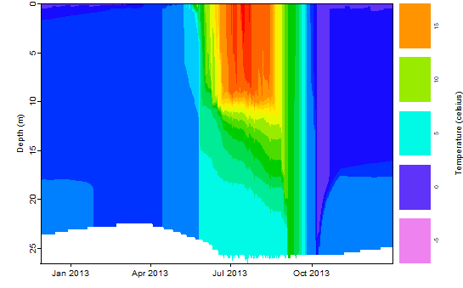

Example ice cover line plot from Toolik, Alaska:

Note: some lakes do not have ice cover! Those line plots will be 0 m throughout.

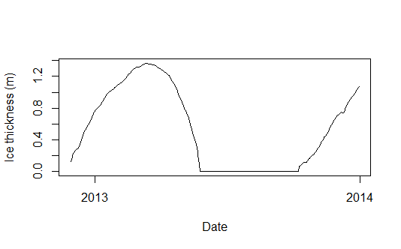

## Activity B

**Objective 3 & 4:** Students will use the R script to estimate El Niño offsets relative to the observed meteorological data by exploring long-term (1970-2017) datasets of mean annual air temperature. They will first calculate the offset for a “typical” El Niño year, which is estimated as the difference between the “neutral” year regression line (neither El Niño nor La Nina; black) and the El Niño year regression line (red) in the year 2013. That temperature offset is then applied to each day of the meteorological driver data.

The “strong” El Niño scenario uses the El Niño year that had the highest mean annual temperature to estimate an offset compared to the “neutral” year regression line. For example, Toolik’s warmest El Niño year occurred in 1993, with a mean annual temperature of -2.0°C. The temperature in 1993 would have been -8.3°C in a “neutral” year, based on the regression line. Therefore, the “strong” El Niño offset for Toolik is +6.3°C relative to the baseline meteorology.

The important part here is that students are able to explain: 1) How their temperature changes in their scenarios, 2) How they predicted the change in climate would change lake thermal structure and water depths (their hypothesis), and 3) Whether the model output supported their hypothesis (and why they think it did/did not).

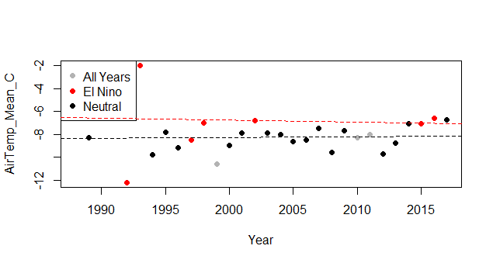

## Activity C

**Objective 5:** After running all three scenarios (baseline, “typical” El Niño, “strong” El Niño), students will produce line plots showing how the surface water temperature and ice cover changed across their three scenarios. Ask students whether their plot provides any evidence of teleconnections, and why? I.e., do they see differences in the lake temperature and ice cover between the baseline and the El Niño scenarios? Do any differences match their hypotheses, and/or the predictions based on the NOAA map?

In the example below (Toolik Lake, Alaska), the El Niño scenarios had warmer surface water temperatures, which were elevated more in the maximum El Niño scenario than in the typical scenario. Temperatures in the hypolimnion also increased in the El Niño scenarios relative to baseline, but to a lesser extent than the surface temperatures. Between the baseline scenario and the “strong” El Niño, Toolik experienced 25 fewer days of ice cover during the model period. You might note to students that these changes reflect El Niño changes that have already happened, and do not take into account future climate warming.

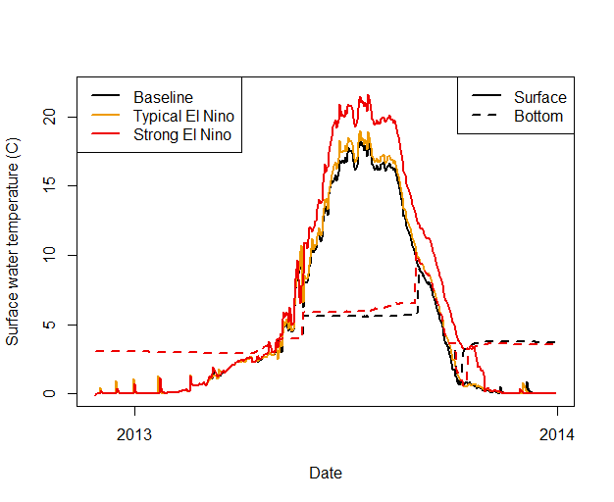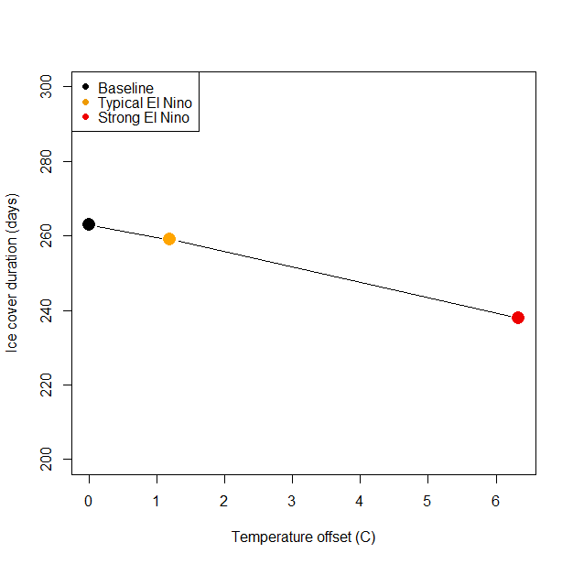

We recommend that student pairs make a very brief presentation to the rest of the class, explaining their three scenarios and sharing figures (e.g., heatmaps, line plots) from the model output that show how their lake changed. We encourage the instructor to ask questions of the students after their presentation to stimulate discussion; starter questions for each lake are listed on the next page.

After all the student groups have presented, we encourage the instructor to moderate a whole-class discussion that explores the regional differences in lake responses to the El Niño scenarios, and what the implications are for understanding how teleconnections affect lake systems.

# Discussion Questions:

### General questions that could apply to all lakes:

* Does your lake show evidence of teleconnections? Why or why not?
* What local characteristics of your lake may have contributed to the responses you saw to your El Niño scenarios?
* Does the model output support or contradict your original hypotheses of how El Niño events will interact with local conditions to affect lake temperatures and ice cover?
* How do you think your lake might respond differently if the El Niño scenarios also include changes in precipitation? Why or why not?
* It’s important to note that these El Niño air temperature scenarios are based on historical conditions already experienced by these lakes since 1970. How do you expect El Niño effects may change in the future, and what does this mean for lake responses?
* Most research on the effects of El Niño has examined the effects of air temperature on land surfaces; are lakes a good proxy for land surface increases? Why or why not?

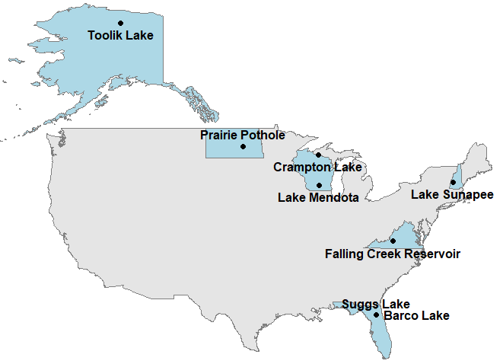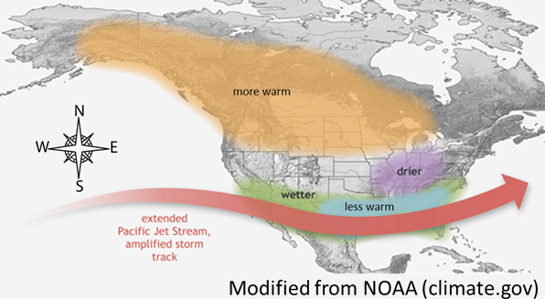

We suggest that instructors have the student pairs present their output in this order, which roughly corresponds to increasing change in response to El Niño:

### **Barco & Suggs (Florida lakes)**

* What’s the value of having two high-frequency monitoring sites so close together? (Note: These two lakes have the same offset because of their geographical proximity- they are both located at the same field station in Florida)
  + Because they have such similar meteorological forcing, we can examine the role of how their small morphological differences in maximum depth and surface area mediate their responses to El Niño (see Lake Characteristics file in the ‘teleconnections’ folder).
* Were Barco and Suggs surface temperatures or bottom temperatures more sensitive to the offset scenarios? Why?
  + Both lakes’ surface temperatures showed small but visible responses; it is harder to observe a difference in the bottom temperatures. This may be because both lakes have primarily subsurface groundwater inflows, resulting in fairly constant temperatures at the bottom of the two lakes, and very weak thermal stratification. Barco receives approximately 0.2 m of groundwater per year, though during storm events, the water table can fluctuate by up to 3 m. Suggs is embedded as part of a wetland complex and thus has short residence times, so the lake likely is much more sensitive to the inflow dynamics than meteorological forcing. Learn more about these two lakes by visiting: <https://www.neonscience.org/field-sites/field-sites-map/BARC> and <https://www.neonscience.org/field-sites/field-sites-map/SUGG>
* What are the differences between Barco and Suggs?
  + Both epilimnetic and hypolimnetic temperatures are warmer in Suggs than in Barco (baseline surface temperature maximum in mid-summer ~22.3°C in Suggs vs. ~19.5°C in Barco; baseline hypolimnion temperature maximum in mid-summer ~20.0°C in Suggs vs. ~17.1°C in Barco). In addition, Suggs begins to stratify earlier in the year than Barco; this is likely due to it being shallower than Barco (Suggs max. depth 5.7 m, mean depth 2.5 m; Barco max. depth 7.1 m, mean depth 4.3 m).
* Why do these lakes not show a response in ice cover?
  + They are too far south to have any ice cover!

### **Falling Creek Reservoir (Virginia)**

* Why might reservoirs not respond in the same way as glacially-formed natural lakes to El Niño forcing?
  + Reservoirs with their shorter residence time are likely less sensitive to meteorological forcing than lakes with long residence times. Falling Creek’s median residence time during the modeling period was ~2-3 months, which is likely why it did not show a large response in temperature to the “strong” offset scenario.
* Why is the bottom water temperature in the strong offset scenario colder for part of the summer than the baseline scenario?
  + As the surface water temperature warms in the strong El Niño scenario, thermal stratification increases, resulting in less mixing of warm surface water into the bottom of the lake during the summer stratified period. Thus, for some stratified lakes, we might counterintuitively expect that bottom waters will be colder than baseline conditions as air temperatures warm.

### **Sunapee (New Hampshire)**

* What are the ecological implications of having fewer days of ice cover?
  + Sunapee had 14 fewer days of ice cover between the baseline and “strong” scenarios. Just half a month of less ice cover can result in substantially greater heat absorption when there is no ice to reflect back radiation, resulting in earlier thermal stratification in the spring that lasts much longer.
* Why are the bottom water temperatures warmer than surface temperatures in the winter?
  + 4°C water is denser than 0-4°C water because of hydrogen bonding, so we actually see inverse stratification in the winter under ice- ice (at 0°C) at the surface is colder than the denser 4°C water near the sediments.

### **Mendota & Crampton (Wisconsin lakes)**

* How might even a small change in surface water temperatures affect the likelihood of algal blooms?
  + Even a 2°C increase has been shown to substantially change competition among algal groups, favoring taxa that produce surface blooms or scums (cyanobacteria).
* What are the other implications of warmer temperatures in a eutrophic (nutrient-rich) lake like Mendota?
  + Less DO (changing habitat for fish, nutrient release from sediments, etc.)
* How might warming temperatures have a different effect in a nutrient-rich lake (like Mendota) vs. a low-nutrient lake (like Crampton)?
  + Higher levels of bacteria/algae/microbes etc. mean that their growth rates are going to be drastically increased: previous studies have shown that climate change will have a disproportionate effect on eutrophic vs oligotrophic lakes
* Mendota and Crampton are located in the same state but have pretty substantial differences: what are the differences and why do they occur?
  + This is likely because they experience a pretty different climate: Mendota is in southern WI and Crampton is in northern WI. This results in maximum temps in Mendota approaching 30°C vs. <20°C in Crampton. In the baseline year, Crampton had over 100 *more* days of ice than Mendota, and lost less ice between baseline and “strong” scenarios despite a larger temperature offset.

### **Prairie Pothole (North Dakota)**

* How would you expect shallow lakes to respond to El Niño differently than deeper lakes (e.g. Mendota or Sunapee)?
  + Due to thermal inertia, water temperatures in Mendota or Sunapee might not exhibit as large of responses to air temperature forcing as smaller lakes like Prairie Pothole. In Prairie Pothole (max. depth 3 m), water temperatures mirror air temperatures in a way that is not observed in deeper lakes with more water volume.
  + In addition, while surface waters in Prairie Pothole exhibit a similar amplitude in temperature changes across the course of a year as in the surface waters of Mendota or Sunapee, but the hypolimnion temperatures in shallow Prairie Pothole were much warmer and more similar to the surface water temperatures than the hypolimnion in Mendota or Sunapee.

### **Toolik (Alaska)**

* Why is Toolik responding more to El Niño than any other lake?
  + ENSO mediates climate globally by creating “planetary-scale wave trains that shift the jet stream and associated weather patterns” (Butler 2016). These can sometimes result in sudden stratospheric warming events (SSWs) that result in much warmer Arctic conditions than other parts of the globe. To learn more, see: https://www.climate.gov/news-features/blogs/enso/el-niño-and-stratospheric-polar-vortex
* In general, the Arctic is warming faster than many other regions due to climate change, which could amplify El Niño events in the future. How much did Toolik warm relative to other lakes, and what does this mean for the biology and chemistry of this ecosystem?

# Temperature offsets in the “strong” El Niño, relative to baseline

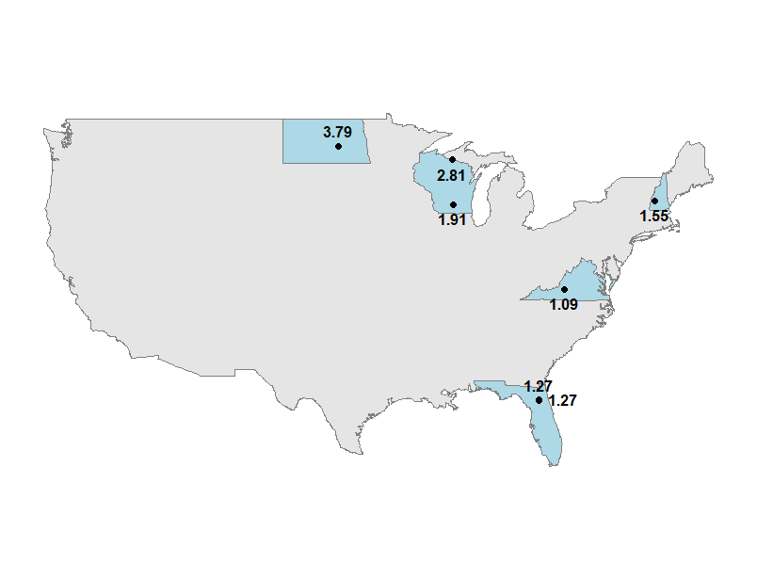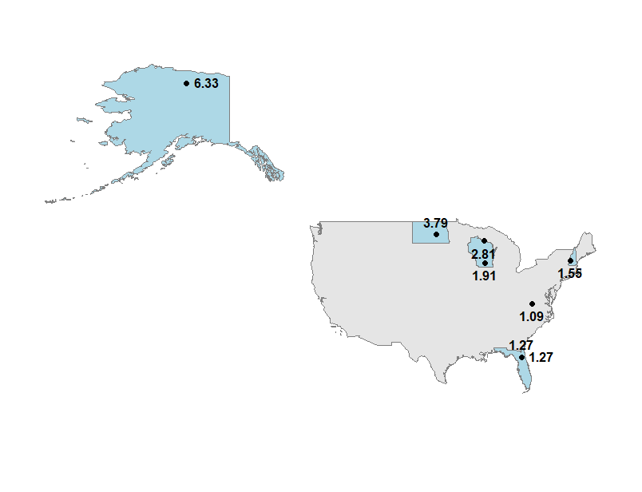

# Change in ice duration (days) during “strong” El Niño, relative to baseline

